The XTrackCAD Wiki : FileFormats

Scale Definition
All Scale Definitions are listed in the file xtrkcad.xtq. This file can be found in /usr/local/lib/xtrkcad on a LINUX system and
in the XTrkCad installation directory on Windows.
(c:\Program Files\xtrkCAD 4.0.3a\share\xtrkcad\xtrkcad.xtq)
The SCALE definition looks like:
SCALE O, 48.0, 1.1770
1536,24,960
2016,30,1200
2592,36,1440
O is the name of the scale,
48.0 is the ratio and
1.1770 is the track gauge in inches.

Easement

The next 3 line define the ‘R’, ‘X’, and ‘L’ values for ‘Sharp’, ‘Normal’ and ‘Broad’ Easement curves. These figures are listed in prototype inches. You can copy these from another scale which is close to the desired scale. The exact values are not critical.

Basic Graphic Elements
Parameter files and Layout files contain the same basic graphic elements.
The lines are (and subject to change):
U this is the information entered on the ‘Turnout Designer’ dialog for this
definition.

P defines the Paths through the turnout. The numbers specify the track
segments, numbered from 1.

E are the turnout's End-Points.

S is a Straight track segment.

C is a Curved track segment.

L is a Straight line.

A is a Curved line.

F is a filled Polyline.

Y is a non-filled Polyline.

G is a filled Circle.

Z is Text String.
The following parameters only show up in the xtrkcad.cus file via the GROUP command.
Q defines a Table-Edge line. Presently unable to determine the parameter
meanings.

B defines a Benchwork line. Presently unable to determine the parameter
meanings.

M defines a Dimensions line. Presently unable to determine the parameter
meanings.
Let's get some of the ‘Basic’s’ out of the way.
Degree ordination is read clock-wise.
(ie, 0 = 12 O'Clock, 90 = 3 O'Clock, 180 = 6 O'Clock and 270 = 9 O'Clock).
Colours values are RGB encoded as (Red*65536+Green*256+Blue).
The RGB Code for BLACK is: 0,0,0.
When encoded this becomes: 0 (0 *65536 + 0 * 256 + 256)
The RGB Code for WHITE is: 255,255,255.
When encoded this becomes: 16777215 (255 * 65536 = 16711680)
+ (255 * 256 = 65280)
+ 255 = 255)
= 16777215
Z values are usually 0 (BLACK) for now.

<sp> will indicate a SINGLE SPACE between or before parameter data for delimiting.
<tab> will indicate a SINGLE TAB SPACE between or before parameter data for delimiting.
All Parameter File Dimensional data is in decimal format (ie, 10.000000).
All Parameter File Angle/Directional data is in decimal format (ie, 90.000000).
It is noted on the Xtrkcad wiki that a ‘Negative’ radius for the "C" and "A" parameters changes the ordination of the swing. However, I find this to be not so.
What I find is that the ‘Start Angle’ and the ‘Degrees of Swing’ are what is important to draw ‘Curve's’ and ‘Arc's’ properly.
The ‘Negative’ radius does do this and corrects miss-alignments in Paths through a turnout but I have been successful in creating L/R turnouts, Wye and 3-Ways without this. Unfortunately, not so with Dbl. Slips and Dbl. Crossovers.
U <sp> "textfield1" <sp> "textfield2" <sp> "textfield3" <sp> dimfield1 <sp> dimfield2 <sp> dimfield3
This is a ‘For Information Only’ parameter.

I have found it only exists in the ‘Parameter File’ if a ‘Track’ object is created with the ‘Turnout Designer’. The ‘textfields’ are delimited by quotes and ‘Dimensional’ fields are delimited by a SINGLE SPACE.

All ‘textfields’ are listed first then ‘Dimensional’ fields.

Since this parameter is ‘For Informational Only’ it is not a required parameter.

P <sp> "textfield" <sp> 1 <sp> 2 <sp> 3 .... etc.
The PATH parameter for track objects only.

Defines the path or multiple paths through a ‘Track’ object.

This is determined by the number of ‘Track Segments’ defined by parameters ‘S’ and ‘C’ and their order in the ‘Track’ object definition.

Let’s see if I can explain this a little better . . .
Here is a sample of a ‘Wye’ turnout definition for a PECO H0 Medium ‘Y’ Turnout – SL-98/198:

S 0 0.000000 0.000000 0.000000 0.353100 0.000000
C 0 0.000000 25.305227 0.353134 25.305227 171.786706 8.213370
S 0 0.000000 3.968199 0.259557 6.500000 0.625000
C 0 0.000000 25.305227 0.352999 -25.305227 0.000076 8.213370
S 0 0.000000 3.968199 -0.259557 6.500000 -0.625000

Shown are five track segment definitions.

They are number starting with 1 in the order they are defined - top down.

So for a left-hand path through the turnout is: 1 2 3
and for a right-hand the path is: 1 4 5.

It is important that the order of segment definition and path definition match.
If not an error will display upon loading the parameter file.

So if you to re-order the above definition:

S 0 0.000000 0.000000 0.000000 0.353100 0.000000
S 0 0.000000 3.968199 0.259557 6.500000 0.625000
S 0 0.000000 3.968199 -0.259557 6.500000 -0.625000
C 0 0.000000 -25.305227 0.353134 25.305227 171.786706 8.213370
C 0 0.000000 25.305227 0.352999 -25.305227 0.000076 8.213370

the path for a left-hand route through the turnout is now: 1 4 2

and for a right-hand route the path is now: 1 5 3.

The ‘textfield’ of the parameter string is just a label. I have yet to determine any purpose other than to indicate the path purpose – usually whether the set route is ‘Normal’ or ‘Reversed’ or ‘Closed’ or ‘Open’.

For turnouts with multiple paths (ie, dbl crossvovers, dbl slips), the paths are define in the following format: 1 2 3 0 7 8 9 for the first pair.

The zero (0) is the delimiter for the second match path.
E <sp> X postion <sp> Y position <sp> Angle
The END-POINT’ parameter for ‘Track’ objects only.

Defines the end-points of a ‘Track’ object.
Each end-point MUST have an entry. However, there is no preferred order to defining the end-points, as far as I have been able to determine.
S <sp> colour <sp> line width <sp> X1 postion <sp> Y1 position <sp> X2 postion <sp> Y2 position
The STRAIGHT TRACK parameter for ‘Track’ objects only.

Defines a straight segment of ‘Track’.
X1,Y1 define the ‘Start Point’ and X2,Y2 define the ‘Ending Point’.

Generally, for a ‘Track’ object the ‘colour’ and ‘line width’ are defaulted to 0 for colour and 0.000000 for line width.
For example: a straight line, defined from left to right, 6" in length and starting at 0,0 would be defined as:

S 0 0.000000 0.000000 0.000000 6.000000 0.000000

C <sp> colour <sp> line width <sp> radius <sp> center-X postion <sp> center Y position <sp> start angle <sp> degrees of swing.
The CURVE TRACK parameter for ‘Track’ objects only.

Defines a curved segment of ‘Track’.

‘centre-X’ and ‘centre-Y’ define the position of the ‘Centre Point of the Radius’.

The ‘start angle’ defines the ‘Start Point of the arc swing’, measured (clock-wise).

The ‘degrees of swing’ defines the ‘Travel(Length) of the Arc’, measured in degrees.

Generally for ‘Track’ object the ‘colour’ and ‘line width’ are defaulted to 0 for colour and 0.000000 for line width.

For example: a curved line, defined from left to right, with a 12" radius, starting at 0,0 swinging down (clock-wise) and a 30 degree swing clock-wise would be defined as:

C 0 0.000000 12.000000 0.000000 -12.000000 0.000000 30.000000

To define the same curve as above but with a up swing (anti-clockwise) it would be defined as:

C 0 0.000000 12.000000 0.000000 12.000000 150.000000 30.000000
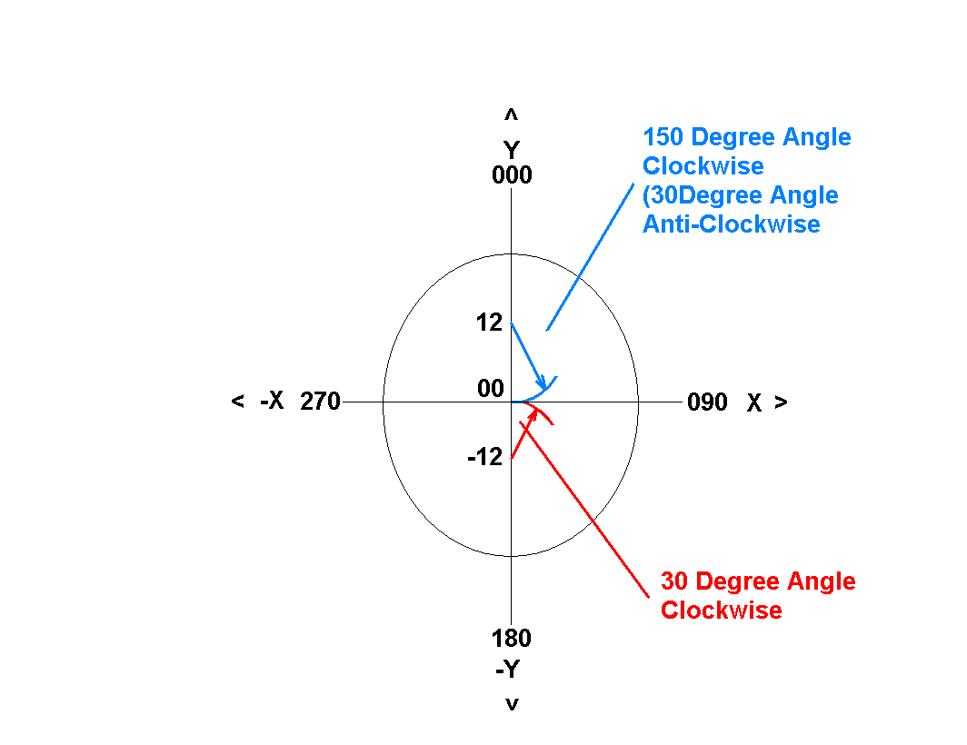

A <sp> colour <sp> line width <sp> radius <sp> center-X postion <sp> center Y position <sp> start angle <sp> degrees of swing.
The ARC LINE parameter for structure and track objects.

Defines an arc or a curved line.

‘centre-X’ and ‘centre-Y’ define the position of the centre point of the radius.

The ‘start angle’ defines the start point of the arc swing, measured (clock-wise).

The ‘degrees of swing’ defines the travel of the arc in degrees.

Generally for track object the ‘colour’ and ‘line width’ are defaulted to 0 for colour and 0.000000 for line width.

For example: An Arc or a curved line, defined from left to right, with a 12" radius, starting at 0,0 swinging down (clock-wise) and a 30 degree swing clock-wise would be defined as:

A 0 0.000000 12.000000 0.000000 -12.000000 0.000000 30.000000

To define the same Arc or Curve as above but with a up swing (anti-clockwise) it would be defined as:

A 0 0.000000 12.000000 0.000000 12.000000 150.000000 30.000000

To define a 12” radius Circle at 0,0 it would be defined as:

A 0 0.000000 12.000000 0.000000 0.000000 0.000000 360.000000
L <sp> colour <sp> line width <sp> X1 postion <sp> Y1 position <sp> X2 postion <sp> Y2 position
The LINE parameter for structure and track objects.

Defines a straight line segment.

X1,Y1 define the start point and X2,Y2 define the ending point.

For example: a straight line defined from left to right, 6" in length and starting at 0,0 would be defined as:

L 0 0.000000 0.000000 0.000000 6.000000 0.000000

F<sp> colour <sp> line width <sp> # of end-points
<tab> X1 <sp> Y1 <sp> 0
<tab> X2 <sp> Y2 <sp> 0
<tab> X3 <sp> Y3 <sp> 0
The FILLED POLYLINE parameter for structure and track objects.

Defines a filled ployline object such as tri-angle, A box or ANY irregular shapes. A minmum of 3 end-points must exist (i.e. a tri-angle).

X1,Y1 define the start point and X2,Y2 define the next point and so on.

There is no need for a closing point as the last point will close/connect back to the starting point.

For example: To define a Filled Polyline for a 2" width and a 1" height (a rectangle/box), starting at 0,0 and with a filled colour of BLACK it would be defined as:

F 0 0.000000 4
0.000000 0.000000 0
2.000000 0.000000 0
2.000000 1.000000 0
0.000000 1.000000 0

Line width for this object is not needed, so can be left at 0.000000 width.

If the total number of end-points do not match the number of end-point definitions an error will occur.

I have yet to determine what the third field for each end point coordinate is? Perhaps a Z-coordinate but unlikely since it's not formatted the same as the X and Y coordinates.

Y <sp> colour <sp> line width <sp> # of end-points
<tab> X1 <sp> Y1 <sp> 0
<tab> X2 <sp> Y2 <sp> 0
<tab> X3 <sp> Y3 <sp> 0
The NON-FILLED POLYLINE parameter for structure and track objects.

Defines a non-fill ployline object such as tri-angle, a box or any irregular shape.

A minmum of 3 end-points must exist (i.e. a tri-angle).

X1,Y1 define the start point and X2,Y2 define the next point and so on.

There is no need for a closing point as the last point will close/connect back to the starting point.

For example: To define a Non-Filled Polyline for a 2" width and a 1" height (a rectangle/box), starting at 0,0 and with a filled colour of BLACK it would be defined as:

Y 0 0.000000 4
0.000000 0.000000 0
2.000000 0.000000 0
2.000000 1.000000 0
0.000000 1.000000 0

Line width for this object is not needed, so can be left at 0.000000 width.

If the total number of end-points do not match the number of end-point definitions an error will occur.

I have yet to determine what the third field for each end point coordinate is? Perhaps a Z-coordinate but unlikely since it's not formatted the same as the X and Y coordinates.

G <sp> colour <sp> line width <sp> radius <sp> center-X postion <sp> center Y position <sp> 0.
The FILLED CIRCLE parameter for structure and track objects.

Defines a filled circle.

X,Y define the center point of the radius.

For example: To define a filled circle starting at 0,0 with a 1"
radius and a filled colour of black would be defined as:

G 0 0.000000 1.000000 0.000000 0.000000 0

Line width for this object is not needed, so can be left at 0.000000 width.
I have yet to determine what the third field for each end point coordinate is? Perhaps a Z-coordinate but unlikely since it's not formatted the same as the X and Y coordinates.

B <sp> colour <sp> unknown <sp> startX <sp> startY <sp> 0 <sp> endX <sp> endY <sp> 0 <sp> lumbersize
BENCHWORK

B 16760832 0.041667 0.000000 0.375000 0 14.000000 0.375000 0 131585

lumbersize
131584 (0010 0000 0010 0000 0000)=1x1 on edge
131585 (0010 0000 0010 0000 0001)=1x1 flat
132096 (0010 0000 0100 0000 0000)=1x2 on edge
132097 (0010 0000 0100 0000 0001)=1x2 flat
132608 (0010 0000 0110 0000 0000)=1x3 on edge
132609 (0010 0000 0110 0000 0001)=1x3 flat
133120 (0010 0000 1000 0000 0000)=1x4 on edge
133121 (0010 0000 1000 0000 0001)=1x4 flat
133632 (0010 0000 1010 0000 0000)=1x5 on edge
133633 (0010 0000 1010 0000 0001)=1x5 flat
134144 (0010 0000 1100 0000 0000)=1x6 on edge
134145 (0010 0000 1100 0000 0001)=1x6 flat

263168 (0100 0000 0100 0000 0000)=2x2 on edge
263169 (0100 0000 0100 0000 0001)=2x2 flat
263680 (0100 0000 0110 0000 0000)=2x3 on edge
263681 (0100 0000 0110 0000 0001)=2x3 flat
264192 (0100 0000 1000 0000 0000)=2x4 on edge
264193 (0100 0000 1000 0000 0001)=2x4 flat
265216 (0100 0000 1100 0000 0000)=2x6 on edge
265217 (0100 0000 1100 0000 0001)=2x6 flat
266240 (0100 0000 0000 0000 0000)=2x8 on edge
266241 (0100 0000 0000 0000 0001)=2x8 flat

526337 (1000 0000 1000 0000 0001)=4x4 flat

M <sp> colour <sp> unknown <sp> startX <sp> startY <sp> 0 <sp> endX <sp> endY <sp> 0 <sp> typesize

DIMENSION LINE

Typesize: 0=Tiny, 1=Small, 2=Medium, 3=Large
Q <sp> 0 <sp> 0.187500 <sp> startX <sp> startY <sp> 0 <sp> endX <sp> endY <sp> 0

TABLE EDGE
Q 0 0.187500 12.000000 36.000000 0 48.000000 36.000000 0
Z <sp> Colour <sp> X Offset <sp> Y Offset <sp> Text Rotation(Degree) <sp> 0 <sp> Text Height <sp> "Text String"
TEXT

Z 0 0.000000 0.000000 0.000000 0 18.000000 "xxxxxxxxxxxxxxxxxxxxxx"

Parameter Files
There are three file structure ‘Header’ parameters of any parameter file as follows:
CONTENTS file title
Required as the first line of the parameter file.
Followed by the Title of the parameter file and the Purpose which is also required.
This Title Description displays in the ‘Content Navigation’ menu upon right
clicking the ‘Object’ bar but only if there are no SUBCONTENTS headings.
SUBCONTENTS Subcontents title
Not required but gives parameter file good organization structure and
allows for users to navigate the ‘Object’ bar easier.
Followed by a Title of the Subcontents. This Title Description displays
in the ‘Content Navigation’ menu upon right clicking the ‘Object’ bar.
# comment description
Can be used anywhere in the parameter file for commenting purposes.
There are three ‘Object’ parameters used to define Track objects, Structures/Misc objects and Rolling Stock/Motive Power objects, as follows:
TURNOUT Defines all Track objects (i.e. Turnouts, Crossings, Bridges, Straight sectional track, Curve sectional track, etc).
STRUCTURE Defines all objects NOT Track or Rolling Stock/Motive Power
(i.e. Buildings, Trees, etc).
CARPART Defines all Rolling Stock and Motive Power.

These ‘Object’ parameters - TURNOUT, STRUCTURE and CARPART - must have a closing parameter of:
END to indicate the end of the object definition.

XTP files define each ‘Object’ to be inserted or used in a layout file (XTC). They have the following format : (for a turnout for example)
TURNOUT .... header line
P ... paths
E ... endpoints
S ... straight track segments
C ... curved track segments
L ... straight line segments
A ... curved (arc) line segments
‘Graphic’ objects that are drawn first (top down) are the lowest object when inserted into a layout, so the order in which objects are drawn will determine the outcome of how your turnout or structure will display.
TURNOUT <sp> scale <sp> "textfield1 <tab> textfield2 <tab> textfield3"
The TURNOUT parameter has two basic parameters - Scale and a quote delimited Textfield.

Scale - is the scale the object is being created for (ie, N, HO, O, etc).

Textfield - is created from 3 text boxes from the ‘Turnout Designer’ dialog
mfg. box, L or R description box and L or R part no. Box.

If this is other than a std. LH/RH turnout then it is only mfg. box, description box and part no. box.

These 3 text fields are delimited inside the quotes by tab spaces only.

STRUCTURES are similar but with only L and A lines and no path or endpoint requirements.

STRUCTURE <sp> scale <sp> "textfield1 <tab> textfield2 <tab> textfield3"
The STRUCTURE parameter has two basic parameters – ‘Scale’ and a quote delimited ‘textfield’.

Scale - is the scale the object is being created for (ie, N, HO, O, etc).

For the STRUCTURE parameter, a non-scale specific parameter file can be created by using an *.

This allows the parameter file to be used with any scale (i.e. A Tree parameter file). If something is define as 1" long it is 1" long for ALL scales.

textfield - is created from 3 text boxes from the GROUP command dialog
mfg. box, description box and part no. box.

These 3 text fields are delimited inside the quotes by tab spaces only.

The following is the information used to define rolling stock and motive power parameter files.
Use the following format for a non-scale or Prototype specific parameter file.
All dimensions (in inches) should be in prototype lengths.
CARPART <sp> "Description" <sp> 0 <sp> Type <sp> Car Length <sp> Car Width <sp> 0 <sp> 0 <sp> Truck Center <sp> Overall Coupler Length
These are the Type codes:

10101(Diesel), 10201(Steam), 10301(Electric), 30100(Freight), 50100(Passenger), 70100(M-O-W) or 90100(Other)

The ‘Option’ before the ‘Type’ code is defined as being:
either 0 for SQUARE lead end or 2 for an ANGLED lead end of the stock item.

There are two 0 options between the ‘Car Width’ and ‘Truck Centre’ dimensions the use of these options have yet to be determine.

A parameter file created using the following example format can be used with any scale.

CARPART "Box, 40'" 0 30100 486.500 126.000 0 0 368.000 518.500
F 255 0.000000 4
0.000000 0.000000 0
486.500000 0.000000 0
486.500000 126.000000 0
0.000000 126.000000 0
L 128 0.013333 40.541667 117.600000 0 40.541667 8.400000 0
L 128 0.013333 81.083333 117.600000 0 81.083333 8.400000 0
L 128 0.013333 121.625000 117.600000 0 121.625000 8.400000 0
L 128 0.013333 162.166667 117.600000 0 162.166667 8.400000 0
L 128 0.013333 202.708333 117.600000 0 202.708333 8.400000 0
L 128 0.013333 244.023048 117.600000 0 244.023048 8.400000 0
L 128 0.013333 283.791667 117.600000 0 283.791667 8.400000 0
L 128 0.013333 324.333333 117.599832 0 324.333333 8.400000 0
L 128 0.013333 364.875000 117.547752 0 364.875000 8.347752 0
L 128 0.013333 405.416667 117.547752 0 405.416667 8.347752 0
L 128 0.013333 445.958333 117.547584 0 445.958333 8.347584 0
END

Any of the following parameter objects can be used to draw body and details for your rolling stock or Motive power (see structure section for usage)
L Defines a straight line.
A Defines a arc or circle.
F Defines a filled polyline.
Y Defines a non-filled polyline.
G Defines a filled circle.

For a Scale specific parameter file - All dimensions (in inches) should be in scale lengths.
CARPART <sp> Scale <sp> "Description" <sp> 0 <sp> Type <sp> Car Length <sp> Car Width <sp> 0 <sp> 0 <sp> Truck Center <sp> Overall Coupler Length <sp> Colour
The Description field has a unique format for Scale Specific parameter files, as follows:

"Manufacturer <tab> X1 <comma> <sp> X2 <comma> <sp> X3 <sp> X4 <tab> X5 <tab> X6 <tab> X7 <tab> X8 <tab> x9"
Some usage I have determine for the following fields:

X1 Car type (ie, Hopper)
X2 Car Desription field 1 (ie, Centerflow)
X3 Car Desription field 2 (ie, 50' ACF 3-Bay)
X4 Car Desription field 3 (any info)
X5 Car Desription field 4 (any info)
X6 Car Desription field 5 (ie, mfg part number)
X7 Full Road Name
X8 Report Markings
X9 Car number

These fields show up in the Car Inventory Edit/Add dialog screens in the following format:

Car Prototype field X1, X2, X3 X4
Part & Description field X6 X5 X8 X9
Full Road Name field X7
Report Markings field X8
Car Number field X9

All fields need to be filled in or data will shift between fields – DO NOT LEAVE ANY FIELD BLANK!!!.

Review some of the existing rolling stock parameter files to get a better understanding of the proper format.

